**Ideation Phase**

**Define the Problem Statements**

|  |  |
| --- | --- |
| Date | 30-10-2025 |
| Team ID | NM2025TMID07992 |
| Project Name | Optimizing User, Group, and Role Management with Access Control and Workflows |
| Maximum Marks | 2 Marks |

**Problem Statement :**

In a small project management team consisting of a Project Manager (Alice) and a Team Member (Bob), there is a need to efficiently manage project tasks and ensure accountability throughout the project lifecycle. The current system lacks clear role definitions, access controls, and a structured workflow, leading to confusion regarding task assignments and progress tracking.

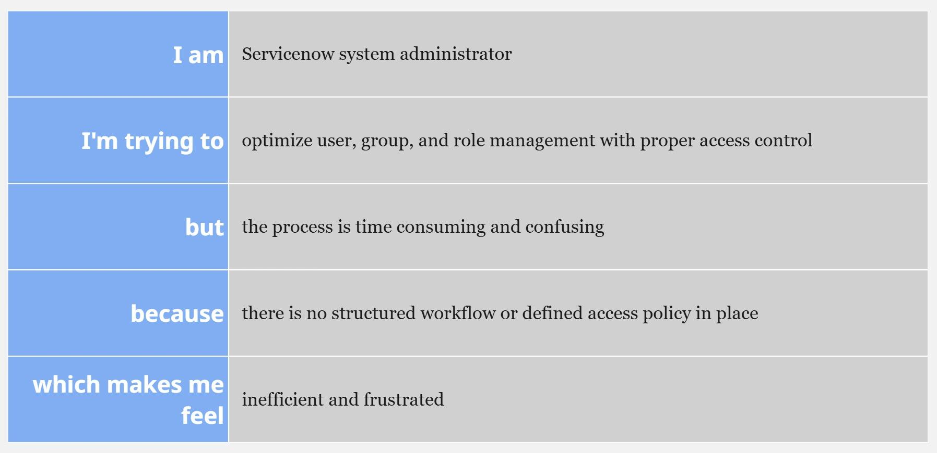

|  |  |  |  |  |  |
| --- | --- | --- | --- | --- | --- |
| **Problem**  **Statement (PS)** | **I am** | **I’m trying to** | **But** | **Because** | **Which makes me feel** |
| PS-1 | A project manager | manage users, roles, and project tasks efficiently | there’s no proper access control or defined workflow | roles and permissions are not automated or clearly structured | frustrated and concerned about task delays |
| PS-2 | A team member | complete assigned tasks and update progress easily | the system doesn’t notify or track my work properly | there is no workflow tracking or progress update mechanism | confused and demotivated |